To have the continuous deployment in the Release pipelines, initially we need to set up the service connection in the Azure

<https://stackoverflow.com/questions/60234886/resource-not-accessible-by-integration-when-trying-to-create-trigger>

1. In the GitHub->Settings-Developer->Generate the PAT.
2. In Azure Service Connection->Add New SC->Select GitHub->Provide the PAT
3. Similarly we can also give the Cluster Service Connection’s as well, once done the AKS is created using the Terraform
4. After Enabling the CD in the release pipelines, it will ask to select the repo. Select n save.
5. Make changes in the github and we can see the pipeline triggers automatically.

**SSL/TLS, Cert Manager and Ingress Nginx**

1. Instruction about all the processes required for the SSL, Cert & nginx. This has single path based routing.

<https://github.com/rameshp1234567/kubernetes-letsencrypt>

1. With multiple path based routing

<https://github.com/MicrosoftDocs/azure-docs/blob/main/articles/aks/ingress-basic.md>

For the **multi-path routing** we need to define the **annotation** with the value else error occurs, and in the path we can have either way (- path: /hi(/|$)(.*) **OR** - path: /h). Prefer to give - path: /hi(/|$)(.*)

**annotations:**

**nginx.ingress.kubernetes.io/rewrite-target: /$2**

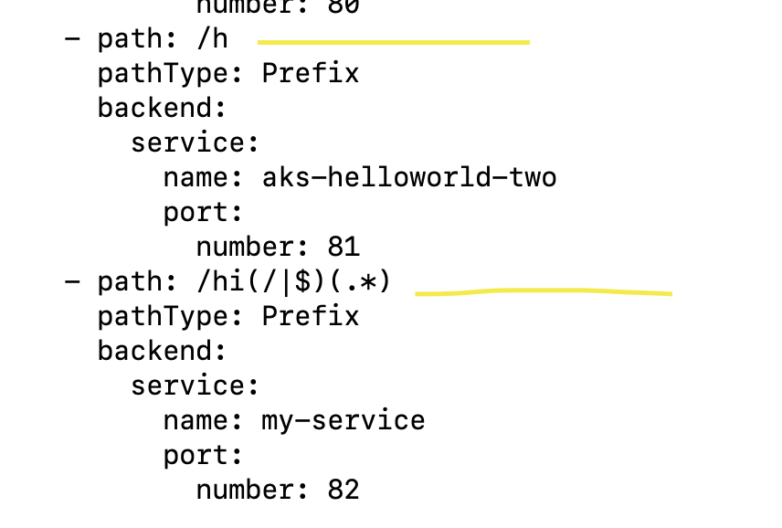

In the ingress to view the paths

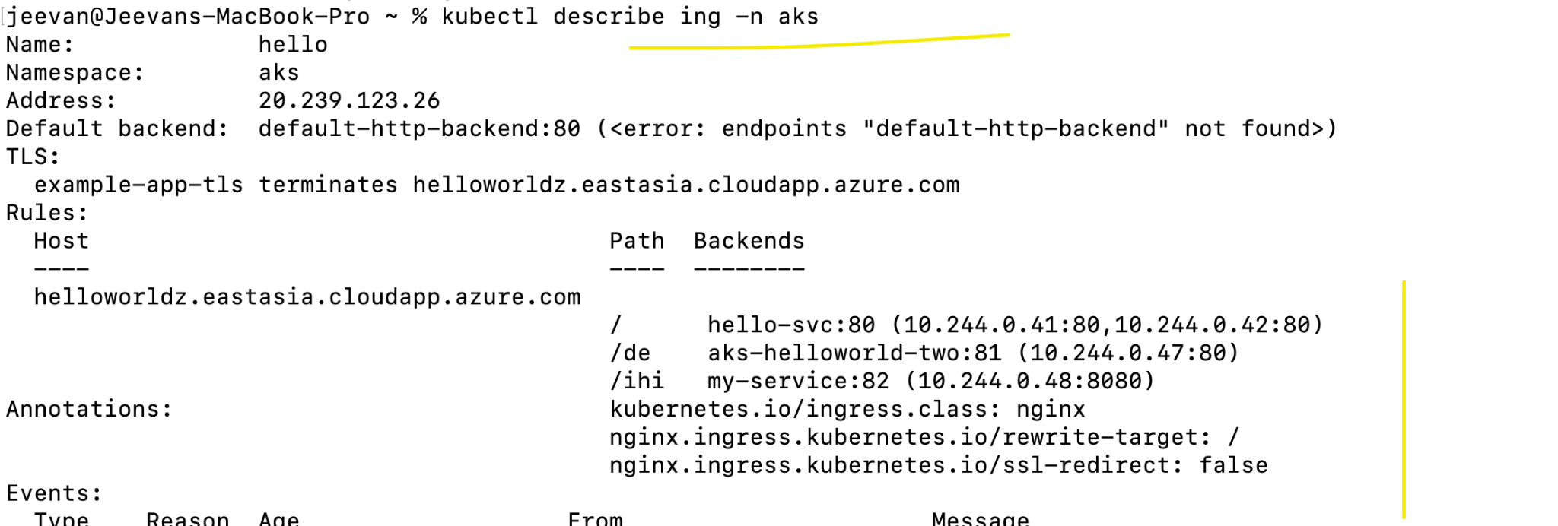

**SSL Certs and app deployment step-by-step process**

<https://github.com/rameshp1234567/kubernetes-letsencrypt>

**Multiple namespaces with single ingress controller and with multiple ingress resources**

<https://vincentlauzon.com/2020/02/11/ingress-rules-in-different-kubernetes-namespaces>

**The github of K8s with Helm**

<https://github.com/kubernetes/>

<https://github.com/kubernetes/ingress-nginx>

**We need the AKS with Private**

<https://www.youtube.com/watch?v=CBUbtf3hQWo>

**Multiple videos on different k8s services**

<https://www.youtube.com/channel/UCD97pyqMp3n_1FMisIjGTPg/videos>

**AGW - with multiple namespaces**

<https://azure.github.io/application-gateway-kubernetes-ingress/features/multiple-namespaces/>

**Apart from Ingress controller we have istio and other external LB**

#########################

In this we have end-to-end step and the roles that needs to be assigned

**AGW AGWIC AGW AGWIC**

<https://jessicadeen.com/tag/aks/>

To view the roles what is assigned to the id

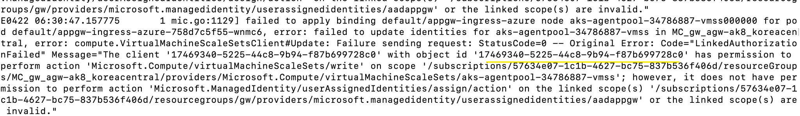

To view what role the client id is holding

​​az role assignment list --all --assignee 17469340-5225-44c8-9b94-f87b699728c0

**The VMSS (MC_***) should have the access of contributor and reader**

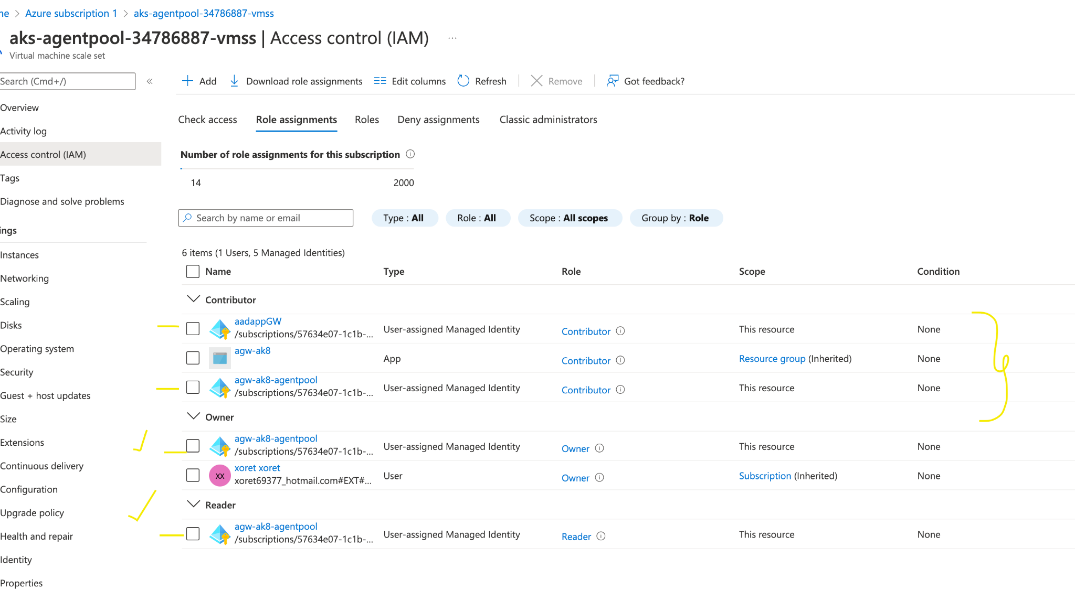

**And the same client id should also have the below role**

az role assignment create --role "Managed Identity Operator" --assignee 17469340-5225-44c8-9b94-f87b699728c0 --scope /subscriptions/57634e07-1c1b-4627-bc75-837b536f406d/resourcegroups/gw

Now we see all the pods are in running

**AGW AGIC**

**Below are the access required for the id '4f738707-e540-4b00-8469-b56e488ecf74'**

1. virtualMachineScaleSets/read

2. virtualMachineScaleSets/write (contributor)

3. ManagedIdentity/userAssignedIdentities/assign/action

**Roles attached to the VMSS**



**Here an (2) additional Role is attached to the owner for agent pool this is not required.**

**Below screenshots shows that agentpool assigned the contributor n reader access. This is enough**

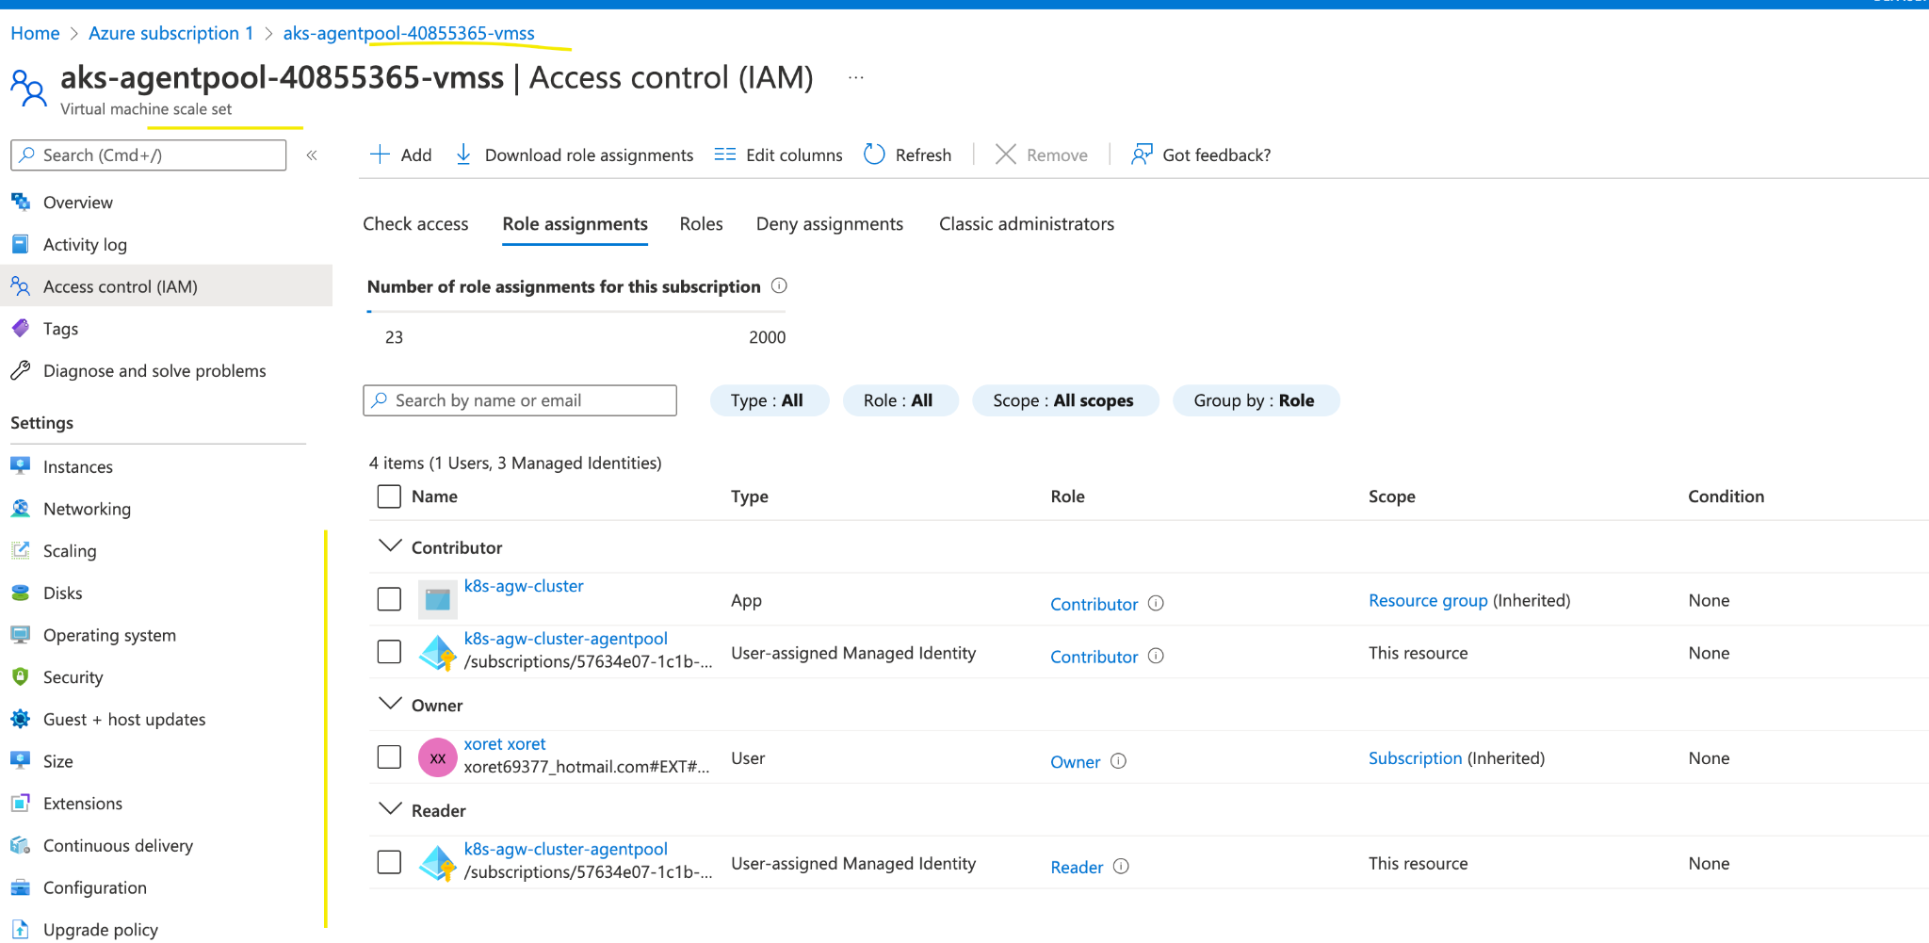

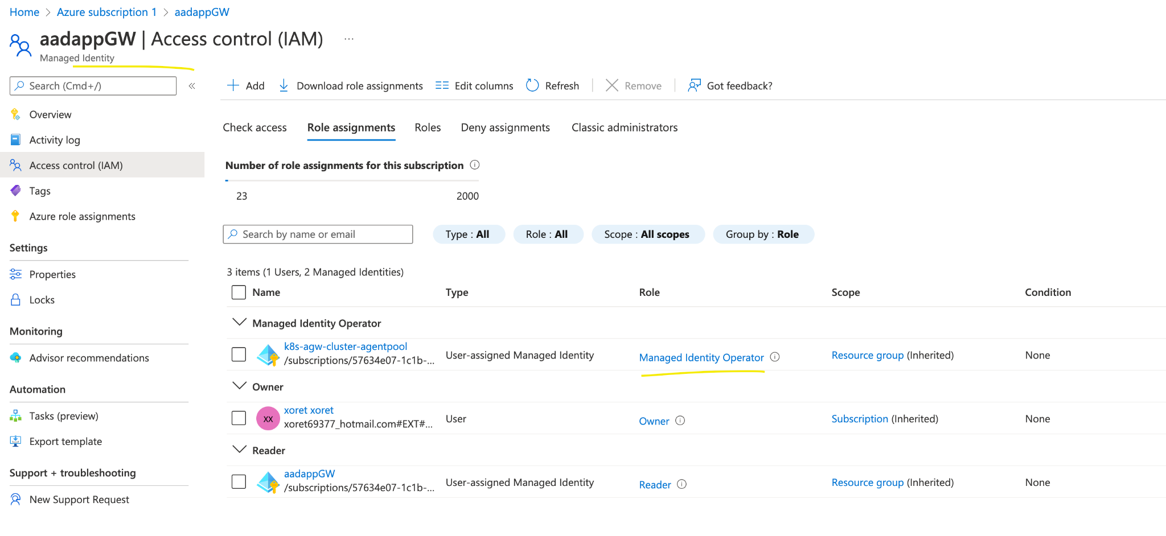

**Command to assign the above role**

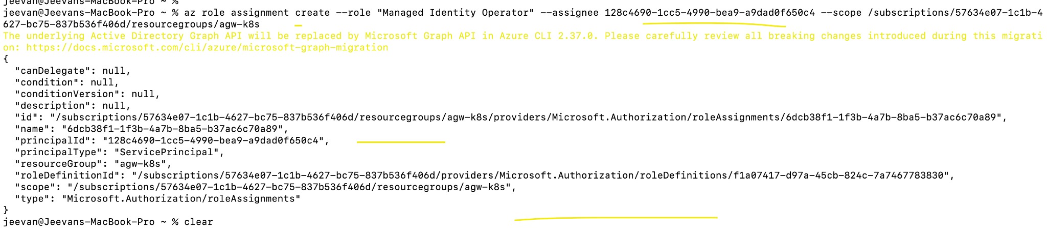

**To view all the roles for the clinet_id/principal_id**

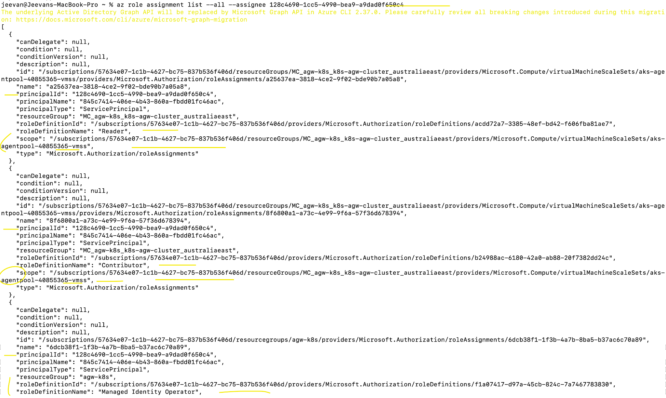

**AGW AGWIC AGW AGWIC**

**SSL PFX Cert**

[**https://www.youtube.com/watch?v=S_imVMFOdhU**](https://www.youtube.com/watch?v=S_imVMFOdhU)

[**https://www.youtube.com/watch?v=-i7ugO8AVN4**](https://www.youtube.com/watch?v=-i7ugO8AVN4)

[**https://www.ibm.com/docs/en/api-connect/10.0.1.x?topic=overview-generating-self-signed-certificate-using-openssl**](https://www.ibm.com/docs/en/api-connect/10.0.1.x?topic=overview-generating-self-signed-certificate-using-openssl)

#########################

**Azure Subscription, Resource Groups and Resources**

1. Created the RG - demo-RG
2. When creating the AKS cluster the other RG got created.

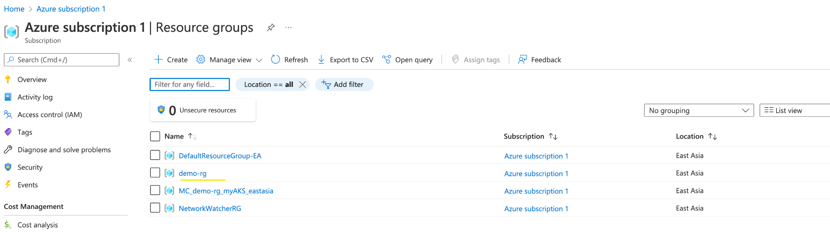

1. Inside the resources tab different resources are created when the AKS is created and they are tagged to the respective RG.

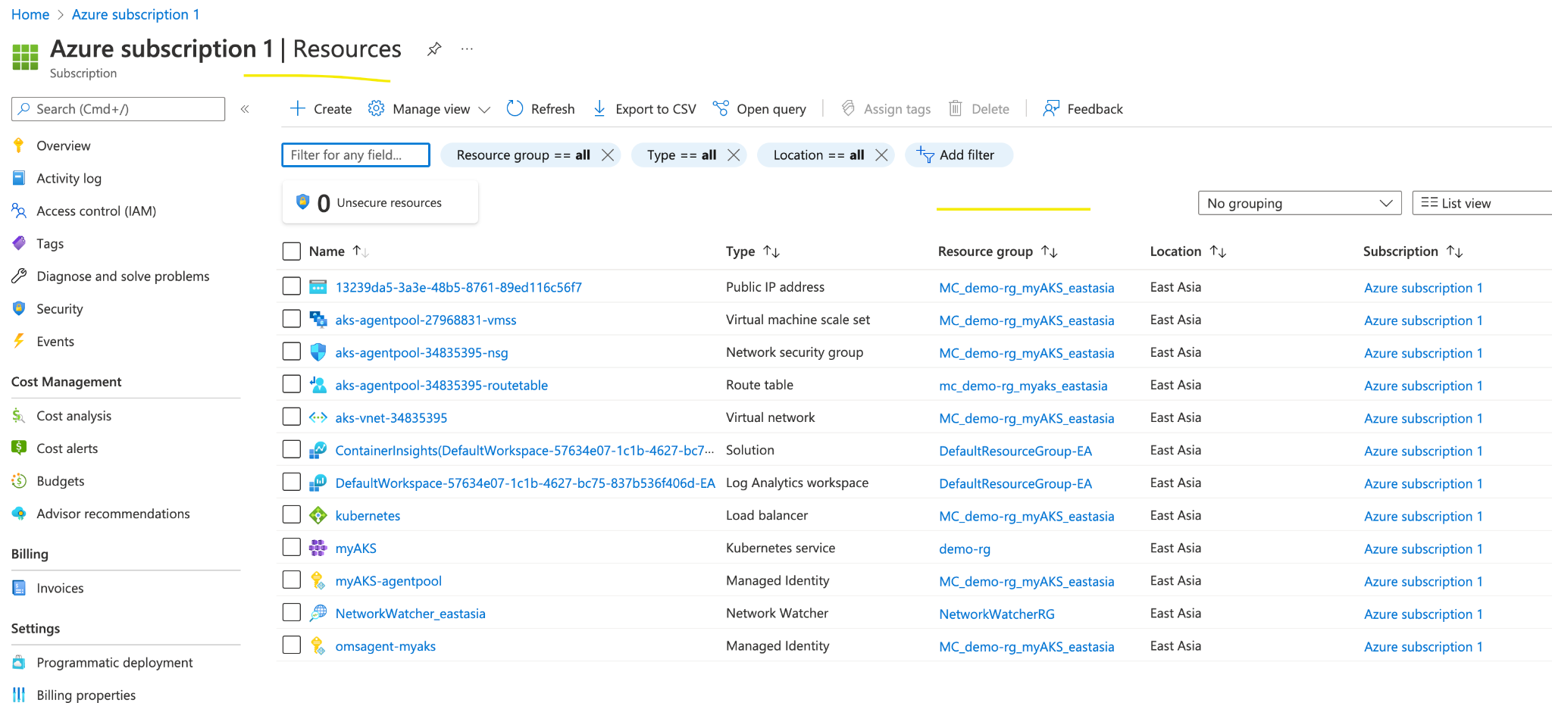

Get to know the insights of the each resource

MC - Managed Cluster

Verify each RG n Resources and compare with the Terraform

See the details of the .kube/config

Why we have this

.eastasia.cloudapp.azure.com

1. We can see the new IP is created when the Ingress and the SVC is created

Hover the IP/Go inside and check the details

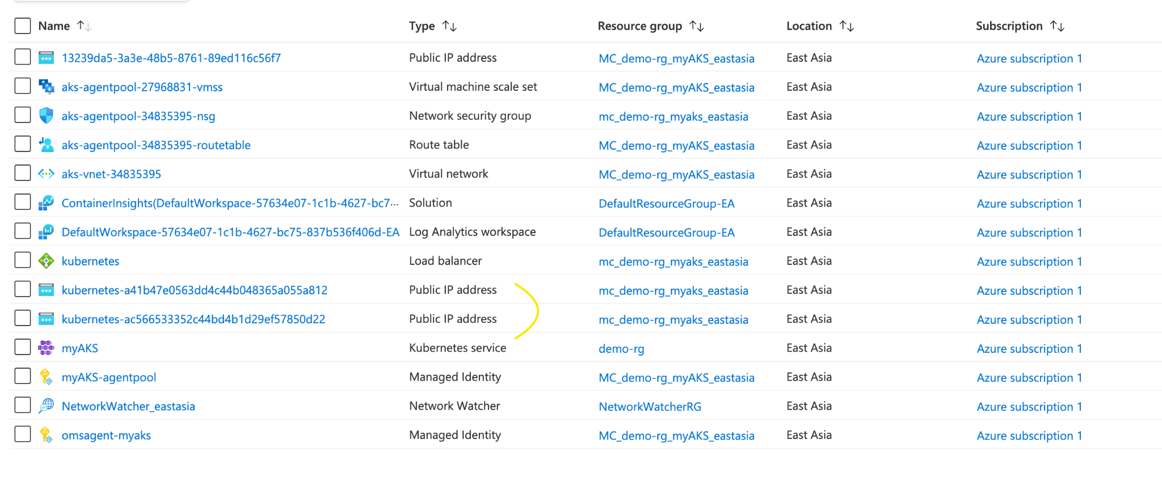

**AGIC**

To install the AAD pod with RBAC n without

<https://github.com/Azure/aad-pod-identity/releases>

**Step-by-Step process of AGW**

<https://github.com/Azure/application-gateway-kubernetes-ingress/blob/master/docs/setup/install-existing.md>

**HELM HELM HELM**

**Helm With sample example and the deployment. Verify both the sessions**

<https://www.youtube.com/watch?v=2dqQcou_MCU>

<https://www.youtube.com/watch?v=ZZVXXEyEzAs&list=PL7iMyoQPMtANm_35XWjkNzDCcsw9vy01b&index=7>

Helm repo creation

<https://medium.com/containerum/how-to-make-and-share-your-own-helm-package-50ae40f6c221>

#########################################################

**Private AKS**

1. Create new RG (private-RG) for the private AKS
2. Once the AKS is created we can view the new RG is created - Managed Container

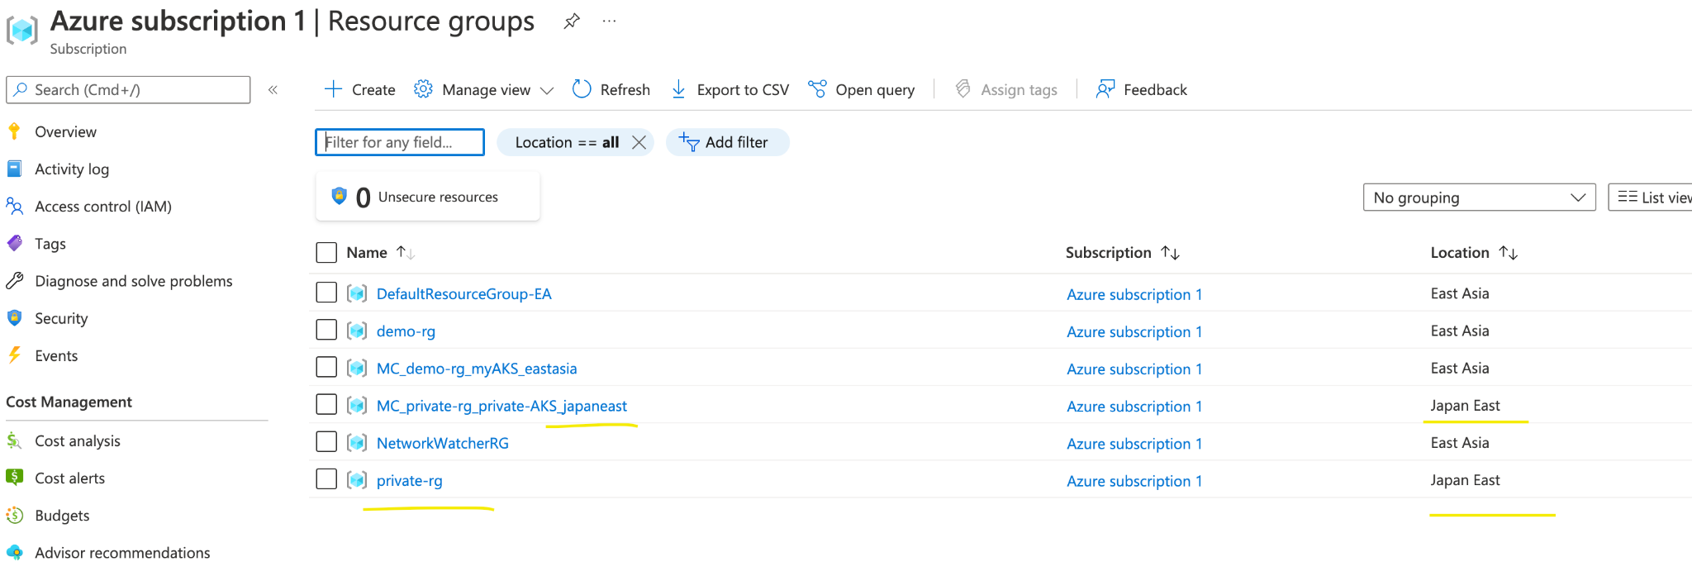

1. Inside the Network Watcher we have the NW for both the East Asia n Japan East.

**Resources for each region**

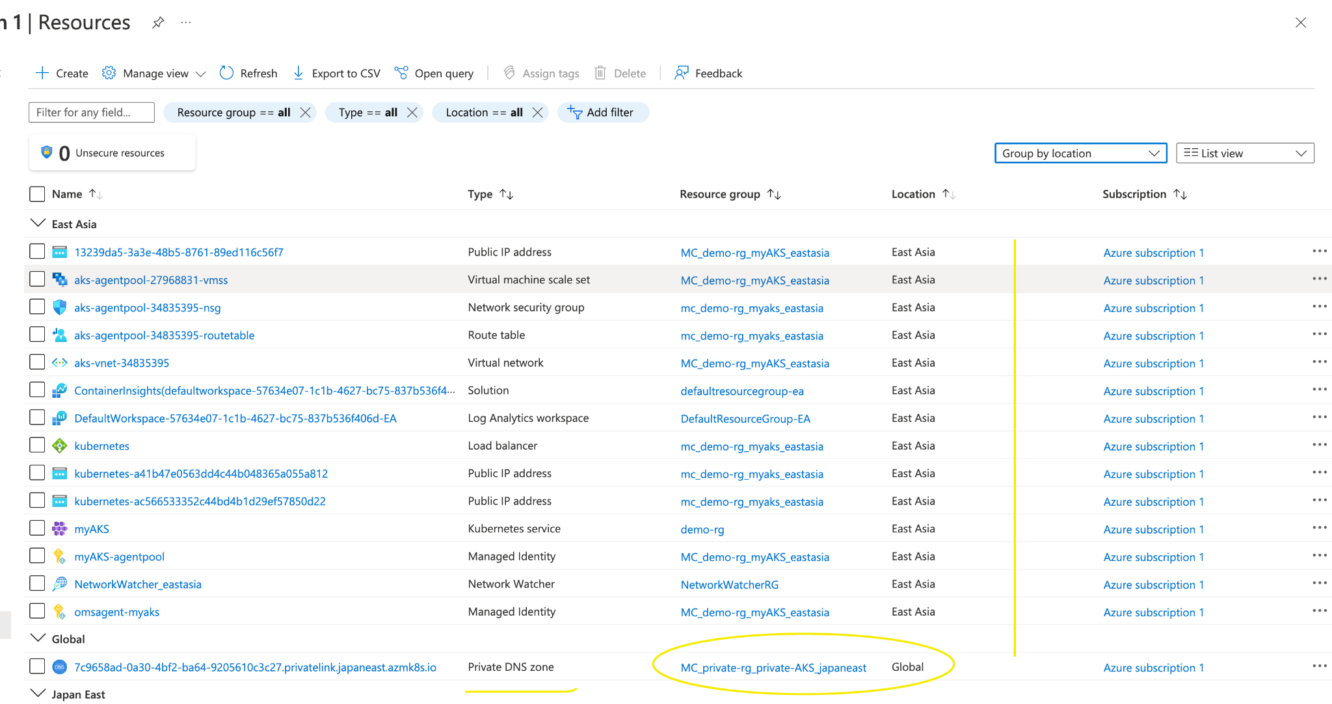

When crated the Private AKS we also got the Private DNS for global

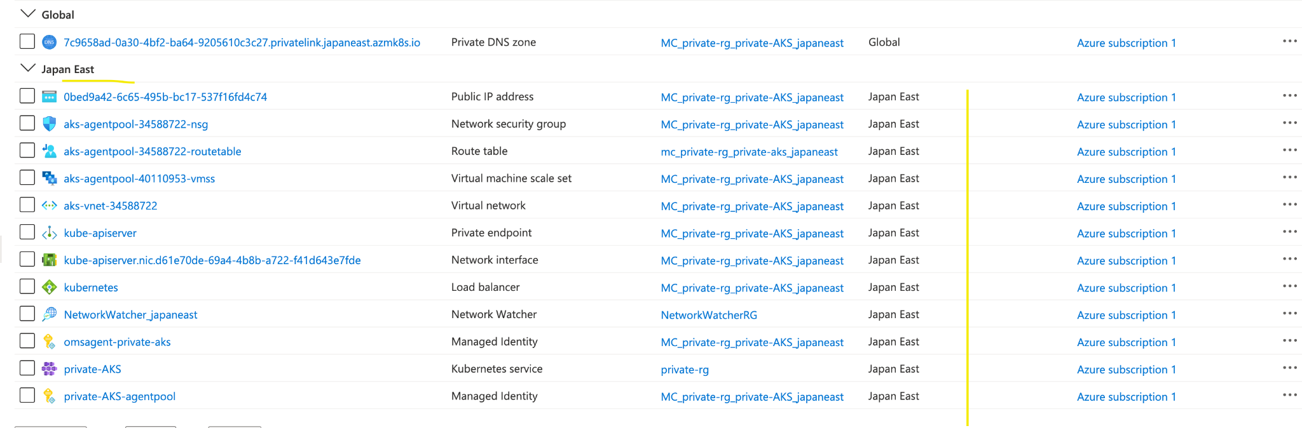

####################################################

**Login Issues occurs**

1. After the installation of Azure CLI

<https://docs.microsoft.com/en-in/cli/azure/>

1. To login we need command az login
2. MFA is also required and install the Azure Authenticator
3. If we cannot login, the error states that the login requires MFA and this MFA will have 7 days of active.
4. We need to try to login via tenant id

Command: az login - -tenant id

1. This will suggest us to give perform MFA

**Multiple cluster in 1 Azure subscription issues**

The config file will gets merged

Merged "private-AKS" as current context in /Users/jeevan/.kube/config

Identify how to resolve this

**###########################################**

**WAF + AGW**

https://www.youtube.com/watch?v=EjQtW8bFzsA

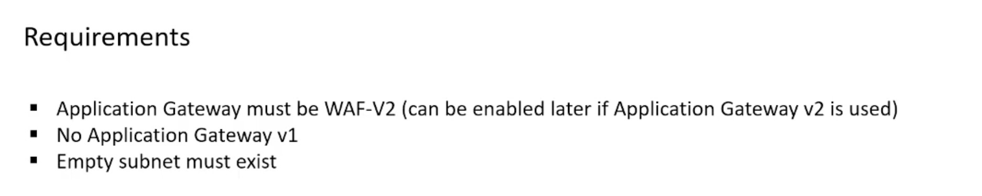

1. Creating this we need WAF-V2 and Firewall mode as **‘Prevention’**. Select the Virtual Network which is already created (empty subnet).
2. FE with Public IP and BE with Private IP or VM or FQDN

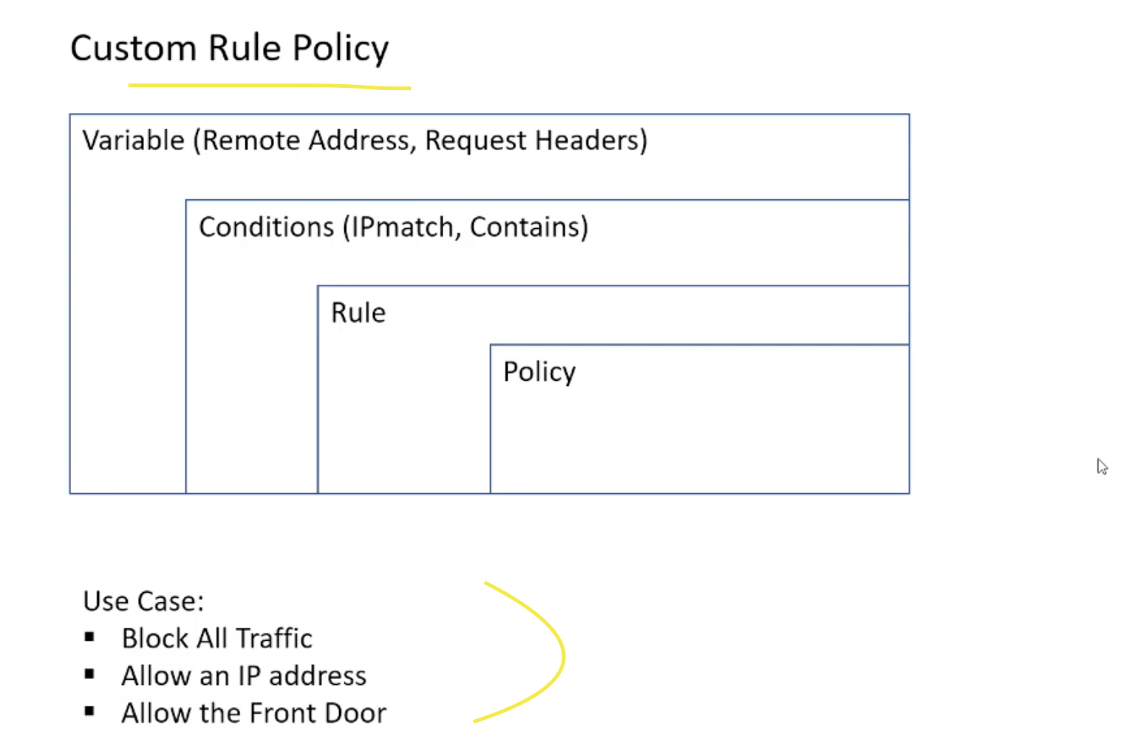

**AGW with sample application**

<https://www.youtube.com/watch?v=ULXhozeoH0U>

**Here we have 2 ways to get the AGW with K8s**

<https://www.youtube.com/watch?v=GkznBbNSq7U>

#########################

AGW Screenshots

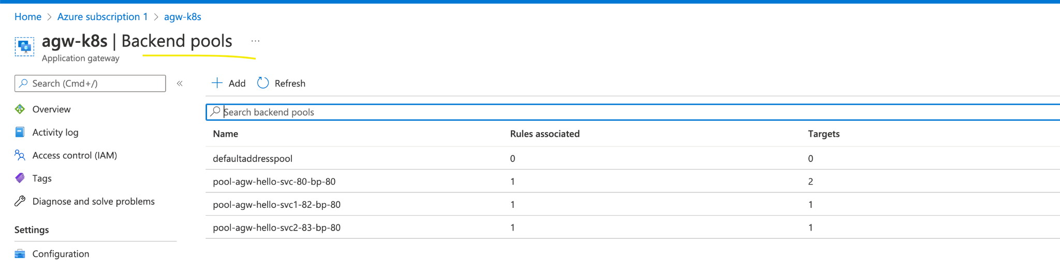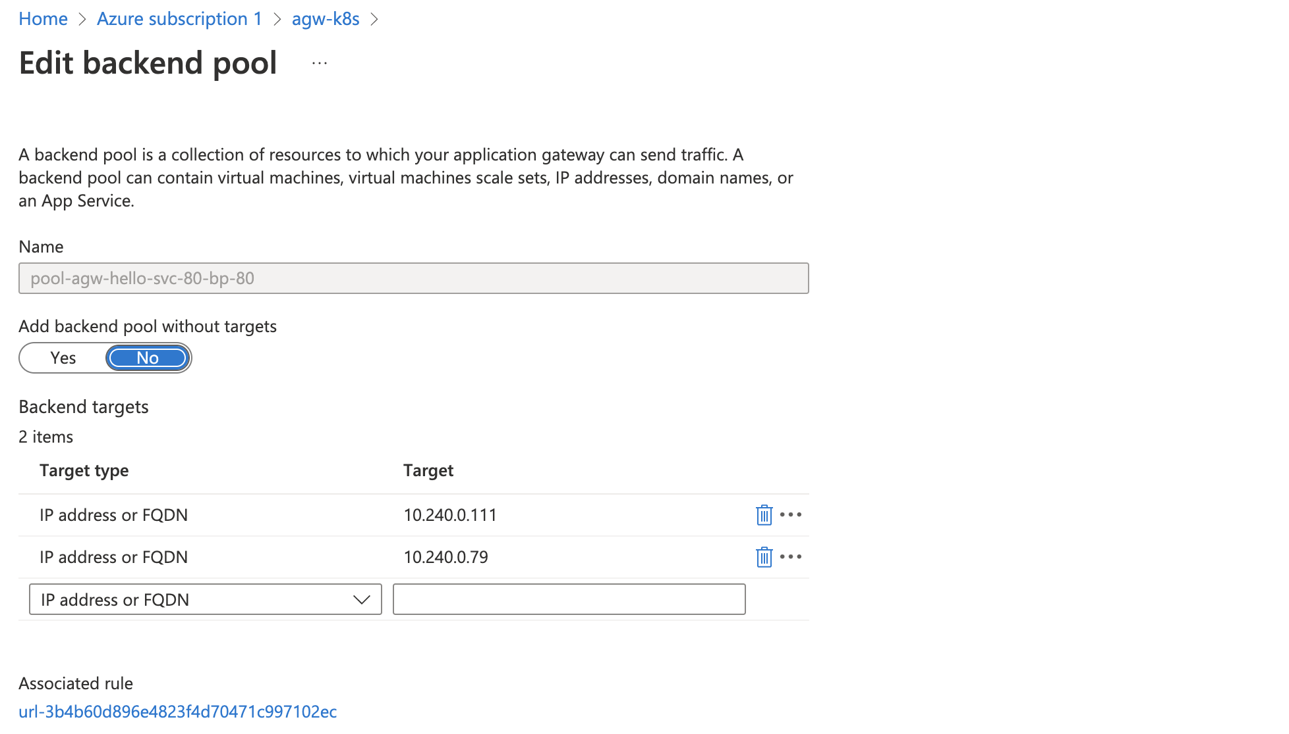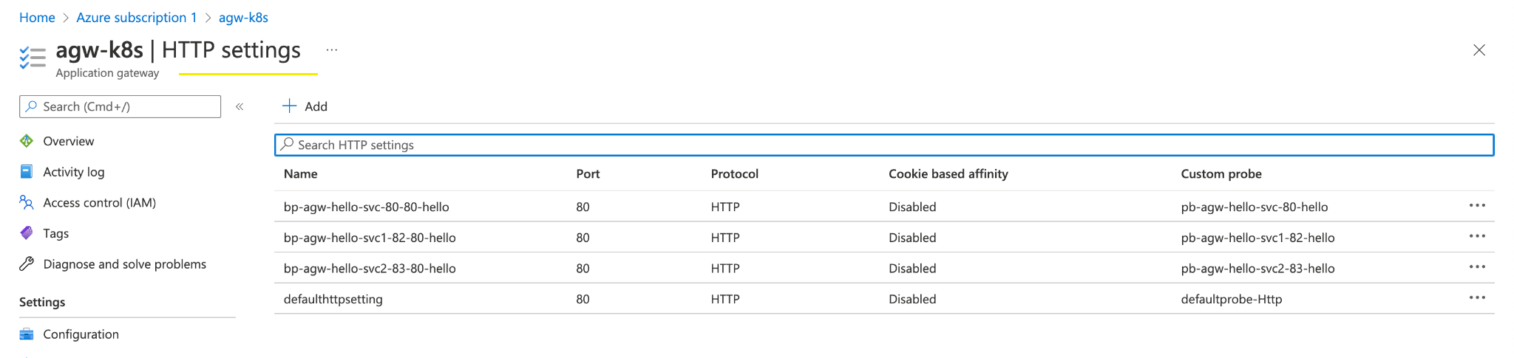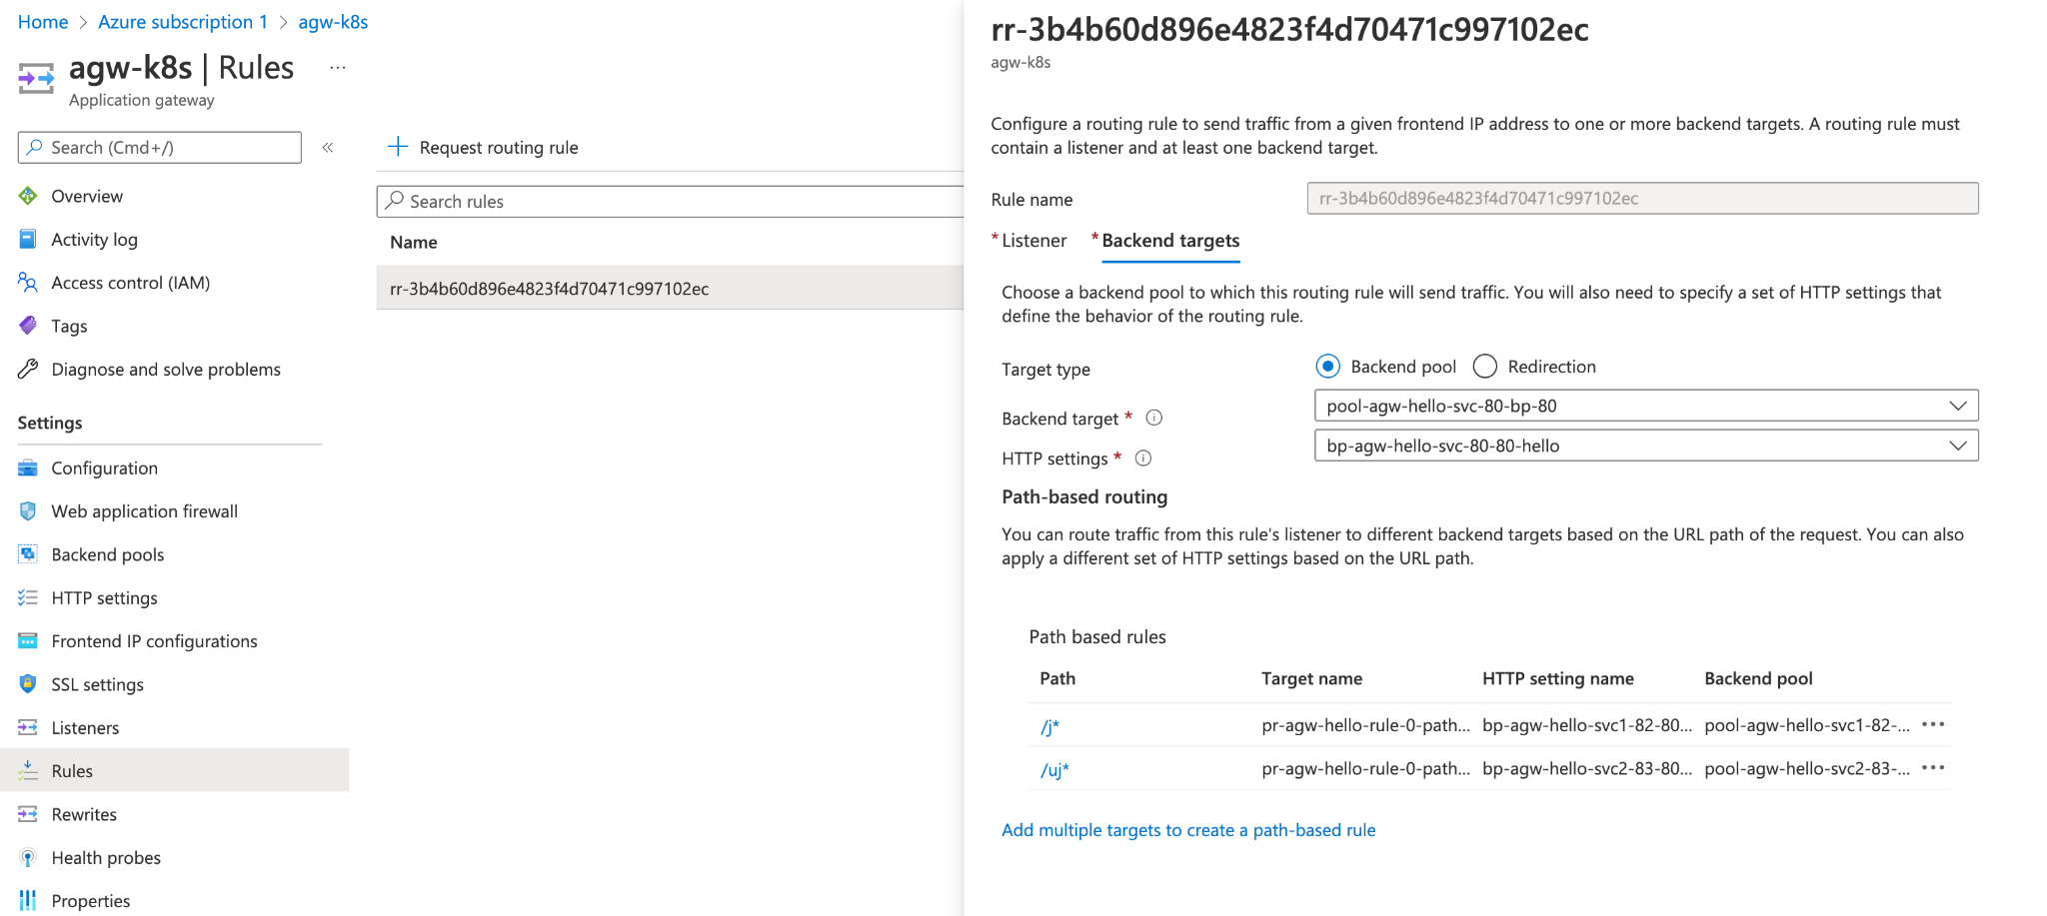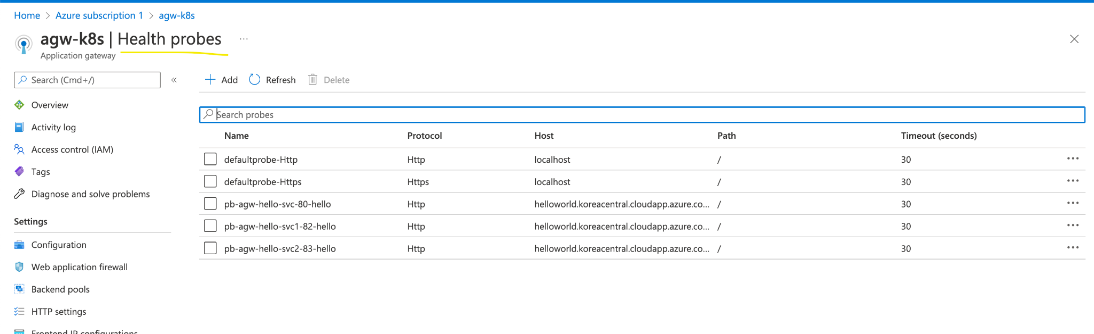

#########################

**#######################################################################**

**Private AKS**

**This requires many things follow the videos and links**

<https://www.youtube.com/watch?v=CBUbtf3hQWo>

<https://www.youtube.com/watch?v=rgj2nSXkzak>

<https://github.com/preddy727/aksprivatecluster>

**After connecting to the Private-AKS**

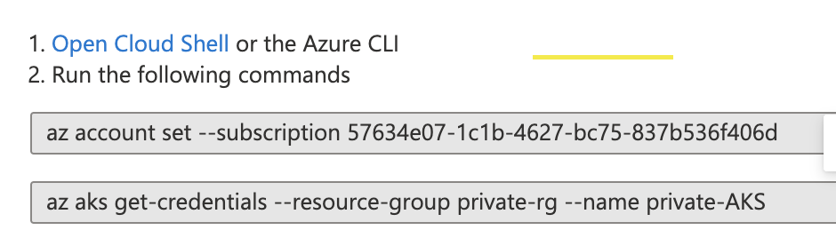

We see the exception

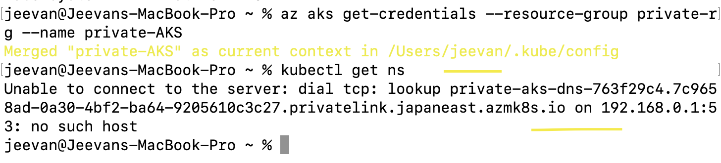

We **cannot access the Private AKS** directly as the AKS assumes the connections are external.

To **connect to Private AKS, we need a Bastion Subnet or a Jump Server.**

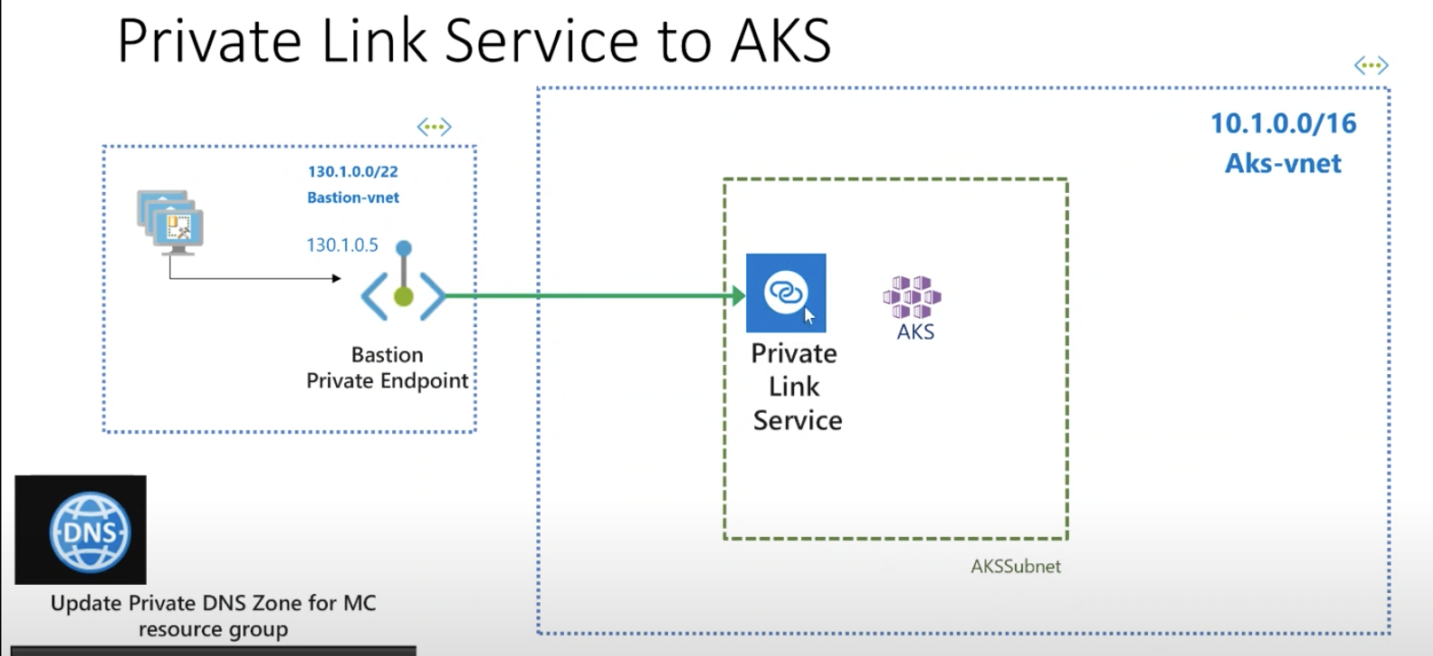

1. **Require Bastion and the private IP to like to the AKS private IP**

